z

PRESS RELEASE

7 May 2019

New Promotions at Allen & Overy

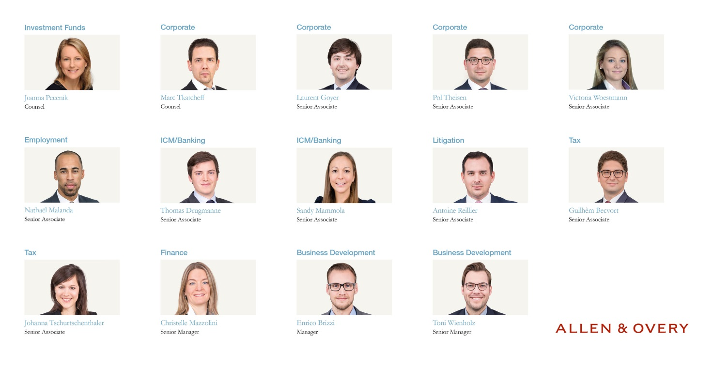
Allen & Overy has announced a new round of promotions in Luxembourg, elevating 2 lawyers to counsel, 9 lawyers to senior associate and 3 in central services effective 1 May 2019. These promotions follow the latest announcement of 3 new partners at Allen & Overy.
The newly promoted lawyers are:
Joanna Pecenik , Investment Funds, Counsel
Marc Tkatcheff, Corporate, Counsel
Guilhèm Becvort, Tax, Senior Associate
Thomas Drugmanne, ICM/Banking, Senior Associate
Laurent Goyer, Corporate, Senior Associate
Nathaël Malanda, Employment, Senior Associate
Sandy Mammola, ICM/Banking, Senior Associate
Antoine Reillier , Litigation, Senior Associate
Pol Theisen, Corporate , Senior Associate
Johanna Tschurtschenthaler, Tax, Senior Associate
Victoria Woestmann, Corporate, Senior Associate

Newly promoted in Central Services
Christelle Mazzolini, Finance, Senior Manager
Enrico Brizzi, Manager, Business Development
Toni Weinholz, Senior Manager, Business Development

Frank Mausen, Managing Partner of Allen & Overy in Luxembourg, comments: “I would like to congratulate our new counsel, senior associates and staff on their promotion. All of our lawyers and staff members possess outstanding expertise in their respective fields to provide our clients with the highest standard of advice. This is a significant and well deserved achievement for all of them.”
Patrick Mischo, Senior Partner of Allen & Overy in Luxembourg added his congratulations: “These promotions reflect the continued commitment of our lawyers and staff towards their profession, which will not only contribute to the success of Allen &Overy but their individual growth as well.”
For further information, please contact Monita Hooda, monita.hooda@allenovery.com, +352 44 44 55 130

Notes for Editors:
1. Allen & Overy is an international legal practice with approximately 5500 people, including some 550 partners, working in 44 offices worldwide.
2. In this press release ‘Allen & Overy’ means Allen & Overy SCS and/or its affiliated undertakings.
3. The term ‘partner’ is used to refer to a member of Allen & Overy SCS or an employee or consultant with equivalent standing and qualifications or an individual with equivalent status in one of Allen & Overy SCS’ affiliated undertakings. www.allenovery.com

