Advantages in purchasing for members of the British Chamber of Commerce
Discount of 6,000 euros on the price and payment of the plane and hotel ticket up to 1,500 euros
Until 12/31/2020 (non-residents)
If you do not want to travel, we have the possibility of meeting on the Digital platform to show you your new home in the Mediterranean
Homes in the most exclusive golf course facing the sea, Murcia / Almería coast
Sports port 10 km
Crystal clear water beaches for you
40 minutes from Almeria with direct low cost flights to Luxembourg
Live, dream, telecommute from Paradise
It has the proximity of the city of Aguilas alive all year round, health, education, commerce, leisure, gastronomy.
Homes from 130,000 euros
We help you in managing your mortgage and health insurance if you need it.
Homes also in Costa del Sol and Portugal
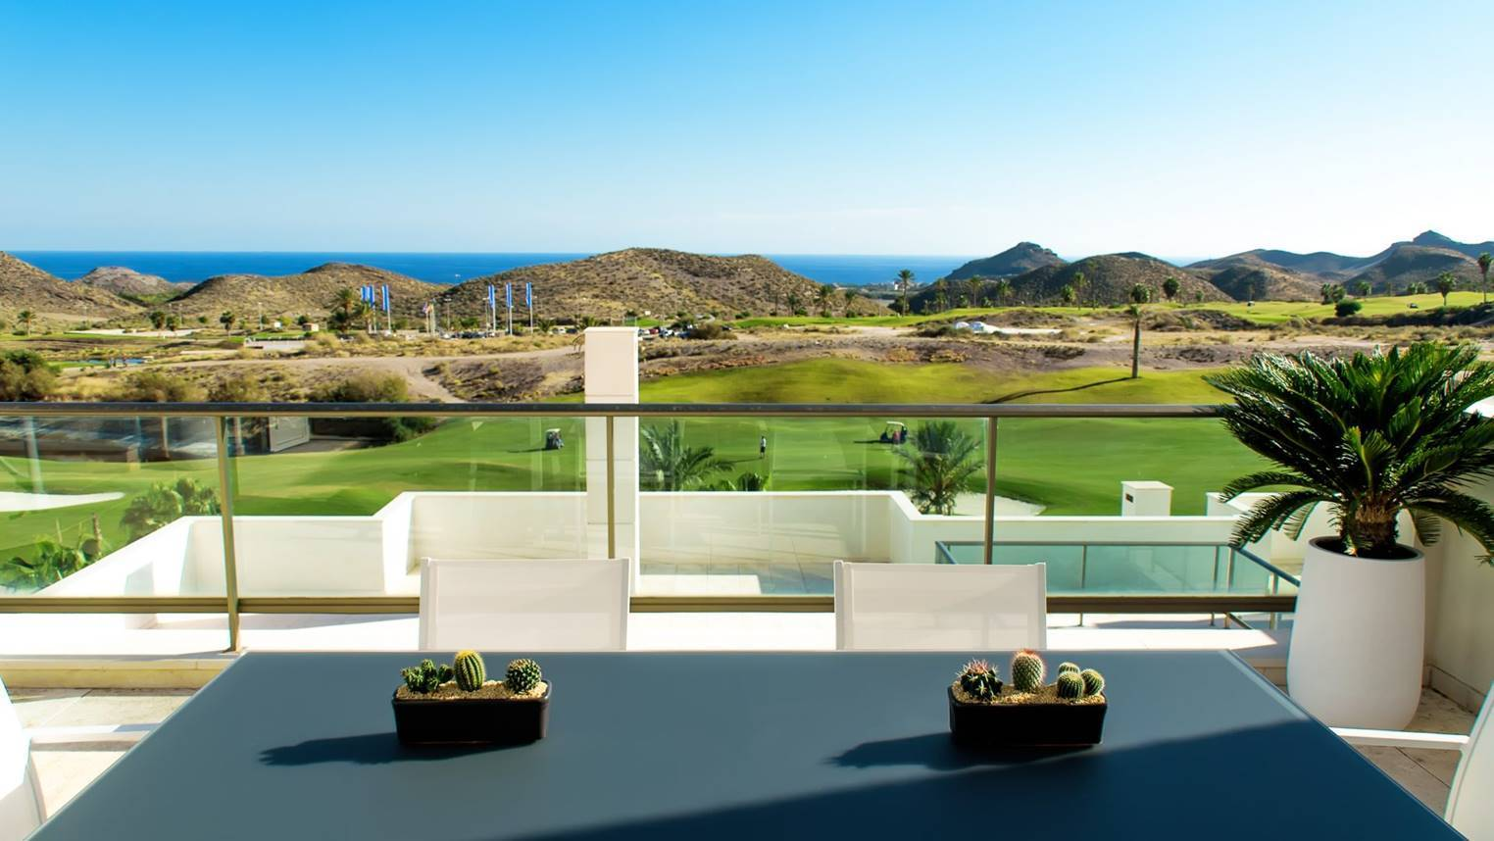

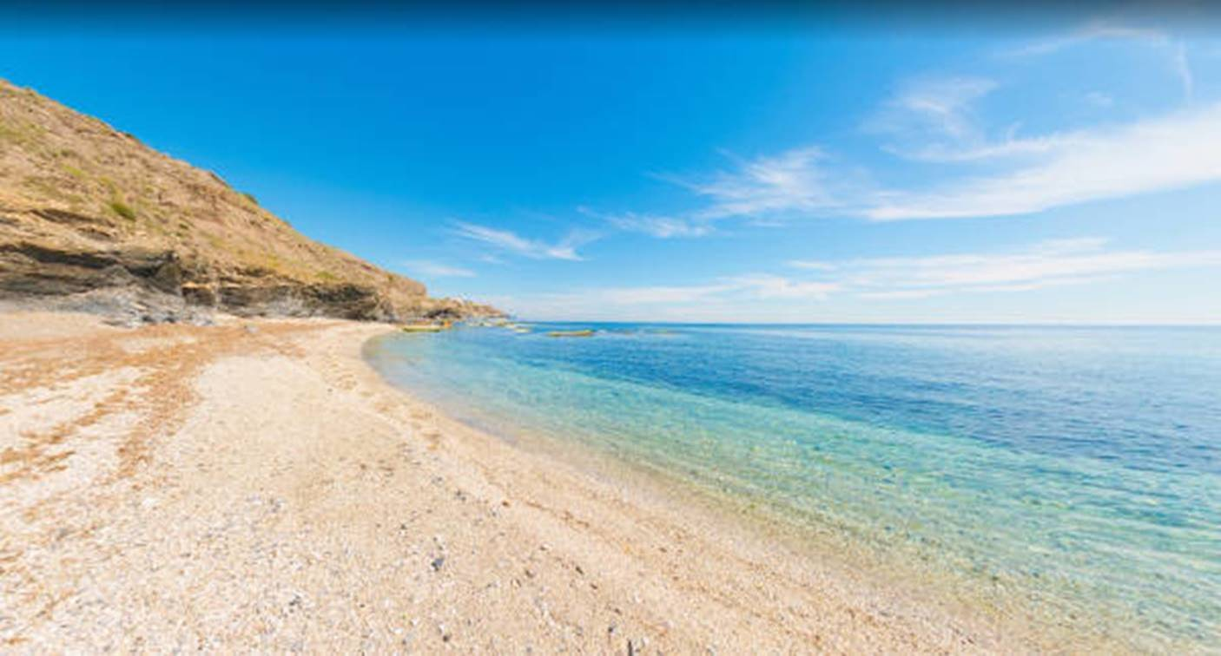

MTSpain
Contacto: Milagros Granizo - milagros.granizo@mtspain.es
www.mtspain.es

