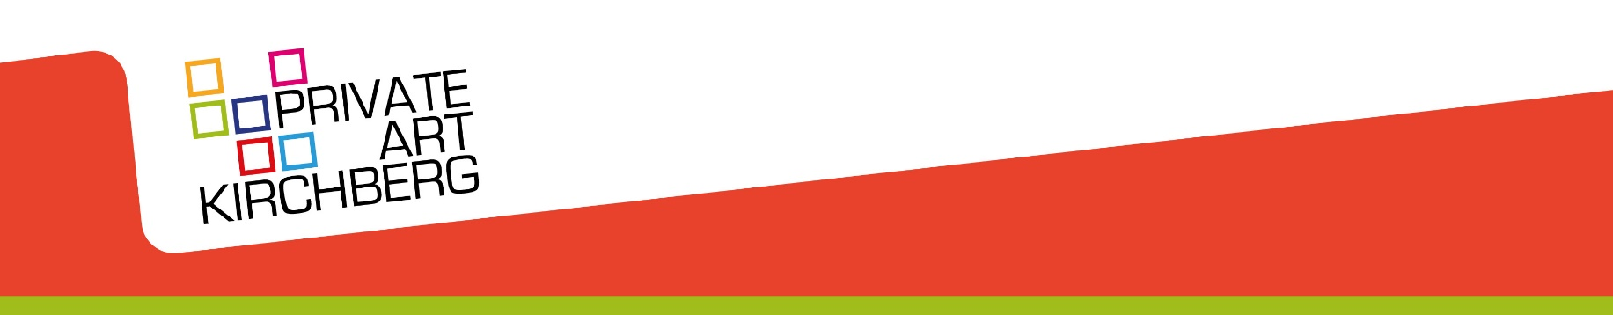

PRESS RELEASE - Luxembourg
1 September 2022

"Private Art Kirchberg" is back: a Sunday to discover private art collections
The Private Art Kirchberg (PAK) initiative, which saw its last edition postponed twice due to the pandemic, is back in shape with seven participating companies and institutions. Allen & Overy, Arendt, the European Investment Bank, Clearstream, Deutsche Bank Luxembourg, Fonds Kirchberg and UBS will open their doors on Sunday 25 September, from 11:00 to 18:00, to unveil their art collections to the public.
In recent years, private art collections have multiplied within companies and institutions in the Grand Duchy of Luxembourg. Thus, the "Private Art Kirchberg" initiative, which began in 2006, was born from a common desire to share hitherto hidden treasures with the general public. It takes place every two years, and since its launch (albeit with two years of cancellations due to the Covid pandemic), art and architecture lovers have had the opportunity to access the premises of participating entities when they are transformed into a public art gallery for the day.
This "Open House" day, which will extend throughout the Kirchberg plateau, is not only an opportunity to understand the commitment and philosophy of these institutions in terms of art, but also to discover another facet of Kirchberg and to encourage a walk through a district usually dedicated to business, shopping and dining.
Visitors will be able to enjoy guided tours of the collections and architecture of Kirchberg, artistic workshops, and discover MUDAM’s “coups de cœur” at each location. Details are available on PAK’s website, http://artkirchberg.lu.
A press conference unveiling the full programme for this edition will take place on Wednesday 14 September at the premises of Allen & Overy, at 5, avenue J.F. Kennedy, L-1855 Luxembourg, at 11:00 am. This will be followed by a networking lunch.

End
For more information, contact Alina Golovkova, by email: alina.golovkova@allenovery.com or by phone +352 44 44 55 234.

