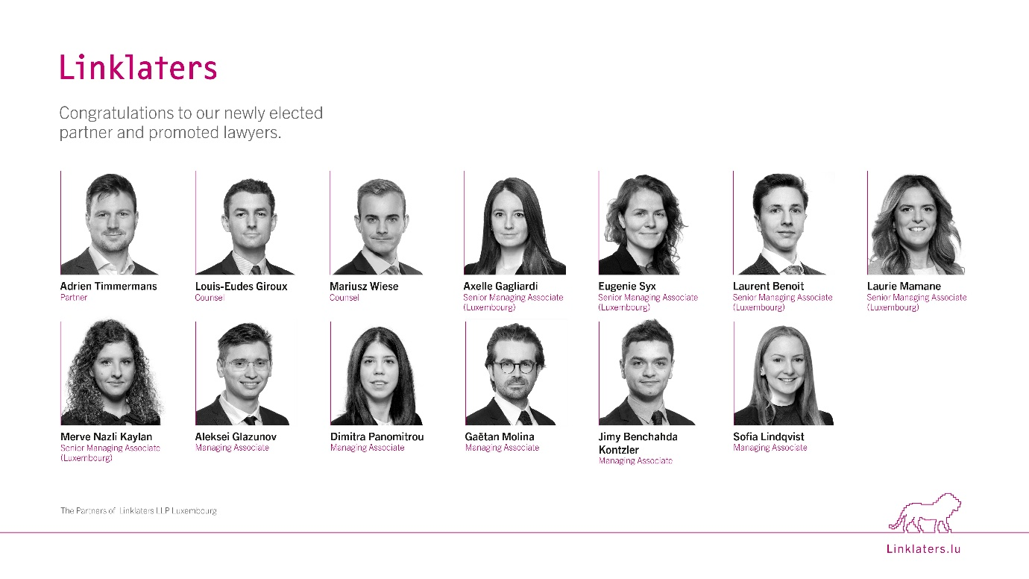
Linklaters announces new partner election and 12 further promotions in Luxembourg effective 1 May.

Adrien Timmermans has been elected Partner in the Investment Funds practice. He has extensive experience advising clients on a broad range of fund structures and strategies, focusing in particular on private equity, real estate, infrastructure, debt and venture capital funds. Adrien has played a key role in supporting the continued growth of the firm’s market-leading funds practice in Luxembourg.

The firm has also appointed two new Counsel: Mariusz Wiese in the Investment Funds practice and Louis-Eudes Giroux in the Litigation, Arbitration and Investigations practice. Both bring strong expertise in their respective fields and are instrumental in delivering high-quality advice to clients on complex and strategic matters.

In addition, the firm recognises the advancement of five Senior Managing Associates (Luxembourg): Laurent Benoit and Merve Nazli Kaylan in Capital Markets & Banking, Axelle Gagliardi and Eugenie Syx in Corporate M&A and Laurie Mamane in Investment Funds. The promotions also include five lawyers appointed to Managing Associate: Aleksei Glazunov, Sofia Lindqvist and Dimitra Panomitrou in Corporate M&A, Jimy Benchahda Kontzler in Investment Funds, and Gaëtan Molina in Tax.

Nicki Kayser, Managing Partner of Linklaters in Luxembourg, commented:
“We are delighted to congratulate Adrien, Mariusz, Louis-Eudes and all our newly promoted colleagues on this significant milestone in their careers. These appointments reflect not only their individual talent and dedication, but also the strength and depth of our Luxembourg team. I am confident that they will continue to contribute to the success of our clients and our firm.”

These appointments underline Linklaters’ ongoing commitment to developing its people and investing in the future of its Luxembourg practice.

End
For further information, please contact Véronique Cioli, Head of Marketing Europe, on +352 2608 8226.
About Linklaters
Linklaters LLP is a leading global law firm, supporting clients in achieving their strategies wherever they do business. We use our expertise and resources to help clients pursue opportunities and manage risk across emerging and developed markets around the world. The firm counts more than 3,000 lawyers worldwide; the Luxembourg office counts 120 lawyers and a total staff of more than 170.

